1. Introduction 2
2. Objective 2
2.1. Primary Objectives 2
2.2. Secondary Objectives 3
2.3. Long-Term / Strategic Objectives 3
3. Methodology 4
3.1. Environment Setup 4
3.2. Page Loading 4
3.3. Extracting Venue Information 4
3.4. Extracting Opening Hours 5
3.5. Structuring the Data 5
3.6. Exporting to Excel 5
4. Tools And Techniques 5
5. Project Workflow 5
5.1. Initialize Selenium WebDriver 5
5.3. Visit Each Venue Page 6
5.4. Compile Data into Python Structure 6
5.5. Export to Excel 6
6. Conclusion: 6

Introduction
The rapid growth of digital booking platforms has transformed how customers discover and schedule beauty, wellness, and personal care services. Among these platforms, Fresha stands out as one of the most widely used systems globally, offering a centralized marketplace where salons and service providers can showcase their offerings. For businesses, analysts, and researchers, the data hosted on Fresha such as venue information, service categories, prices, ratings, and operating hours provides valuable insights into market trends, consumer preferences, competitive landscapes, and pricing strategies.
However, retrieving this information manually is time-consuming, inefficient, and prone to error. Additionally, Fresha dynamically loads its content using client-side JavaScript, meaning that much of the valuable information is not available through simple HTTP requests or traditional web-scraping methods. To overcome this challenge, this project utilizes Selenium, a browser automation tool capable of executing JavaScript and rendering full webpages just like a real user. Selenium enables the script to interact with Fresha’s website, load all dynamic elements, and capture the complete HTML structure required for accurate data extraction.

Objective
The primary aim of this project is to develop a reliable, automated system for extracting structured data from Fresha’s Dubai service listings. By leveraging browser automation and HTML parsing techniques, the project seeks to eliminate manual effort and provide clean, analyzable datasets. The objectives are divided into primary, secondary, and long-term goals to reflect the full scope of the project.

2.1. Primary Objectives
a. Automate Data Collection From Fresha
To create a fully automated scraping tool capable of navigating Fresha’s dynamically loaded content, ensuring that all relevant venue information is retrieved without any manual intervention.
b. Extract Key Venue Details
To accurately capture essential data points for each venue listed on the Fresha Dubai page, including:
- Venue name
- Address or location details
- Customer ratings
- Gender restrictions (e.g., “Men only”, “Women only”, or NA)
c. Scrape Services and Prices
To collect detailed service information displayed on each venue card and ensure proper pairing of:
- Service names
- Service prices
This allows for analysis of service availability, price distribution, and competitive positioning.
d. Retrieve Opening Hours
To visit each venue’s individual page and extract the weekly opening hours (Monday–Sunday), providing a complete operational profile for every business.
e. Organize and Export Data
To structure all gathered data into a clear and readable format and export it as an Excel file, enabling easy downstream analysis, filtering, and reporting.

2.2. Secondary Objectives
a. Ensure Data Accuracy & Completeness
To handle dynamic rendering, missing fields, inconsistent layouts, and potential loading delays to prevent incomplete or inaccurate records.
b. Develop a Reusable and Scalable Script
To design the code in a modular manner so it can be extended to:
- Other cities/countries
- Additional data fields
- More complex scraping scenarios
c. Handle Dynamic JavaScript Content
To implement Selenium-based solutions capable of loading all scripts, dynamic elements, and interactive components that cannot be accessed via normal HTTP requests.

2.3. Long-Term / Strategic Objectives
a. Enable Data-Driven Market Insights
To provide businesses, data analysts, or researchers with actionable datasets for:
- Market research
- Competitor benchmarking
- Pricing comparisons
- Trend analysis
b. Improve Efficiency and Reduce Manual Work
To eliminate the need for repetitive manual data collection, reducing time, effort, and human error.
c. Establish a Foundation for Advanced Tools
To set the groundwork for:
- Automated dashboards
- Predictive analytics
- AI-driven recommendation systems
- Large-scale business intelligence solutions

Methodology
This project follows a structured process to scrape and organize venue information from the Fresha Dubai webpage. Because the website loads content dynamically through JavaScript, Selenium is used to render the page before extracting data. The methodology consists of six main stages:

3.1. Environment Setup
- Configure Selenium Chrome WebDriver in headless mode.
- Import required libraries: Selenium, BeautifulSoup, Pandas, OpenPyXL, and Time.
- Initialize the driver and set browser options for stable performance.

3.2. Page Loading
- Navigate to the Fresha Dubai listing page.
- Use delays to allow all JavaScript-generated elements (venue cards, service previews, etc.) to load fully.

3.3. Extracting Venue Information
- Identify the main container holding all venues.
- For each venue card, extract:
  - Name
  - Address
  - Rating
  - Gender restrictions
  - Services and their prices
- Collect the venue’s individual page URL for further scraping.

3.4. Extracting Opening Hours
- Visit each venue’s dedicated page using Selenium.
- Locate the opening hours table using stable HTML attributes.
- Extract daily hours (Monday–Sunday) or assign “N/A” when missing.

3.5. Structuring the Data
- Store all extracted fields in a dictionary for each venue.
- Clean text, standardize missing values, and align service–price pairs.
- Organize the data into a Pandas DataFrame with dynamic service columns.

3.6. Exporting to Excel
- Export the DataFrame to an Excel file (datas.xlsx).
- Adjust column widths for better readability using OpenPyXL.
- Ensure consistent formatting across all rows.

Tools And Techniques
This project uses several tools and technologies to ensure reliable scraping and data processing. Selenium WebDriver is used to load dynamic, JavaScript-based content that cannot be accessed through traditional HTTP requests, while Chrome WebDriver provides the necessary browser automation to navigate and render the Fresha webpage. After the page is fully loaded, BeautifulSoup is used to parse the HTML content and extract specific elements such as venue details, services, and pricing information. The extracted data is then organized and processed using Pandas, which structures the information into a clean format suitable for analysis. To create a polished and readable Excel output, OpenPyXL is employed for writing and formatting the final dataset. All components of the scraping workflow are built using Python (3.x) as the core programming language, providing flexibility and efficiency throughout the project.

5. Project Workflow

5.1. Initialize Selenium WebDriver
The script first launches Chrome in headless mode, allowing the browser to run in the background without opening a visible window, which improves performance and efficiency. Once the headless browser is initialized, it loads the Fresha Dubai listing page, ensuring that all dynamic elements and JavaScript-generated content are fully rendered before proceeding with data extraction.
5.2. Extract Venue Cards
- Locate the main container
- Loop through all venue blocks
- Extract details such as name, address, services, prices, rating

5.3. Visit Each Venue Page
- Open venue link
- Scrape opening hours from elements containing

5.4. Compile Data into Python Structure
For each venue, the script builds a structured dictionary that holds all extracted information, creating a clear and organized data record. It also stores the lists of services and corresponding prices, ensuring that each service is correctly paired with its price. Additionally, the script maps the opening hours to each weekday, assigning the appropriate time range to Monday through Sunday or marking days as “N/A” when no information is available.

5.5. Export to Excel
The script dynamically creates columns for services and their prices (e.g., Service_1, Price_1, Service_2, Price_2, etc.) based on the maximum number of services found across all venues, then saves the assembled DataFrame as datas.xlsx. After writing the file, it applies simple formatting such as adjusting each column’s width to match the longest cell or header content—to improve readability and ensure the Excel sheet is clean and easy to scan.
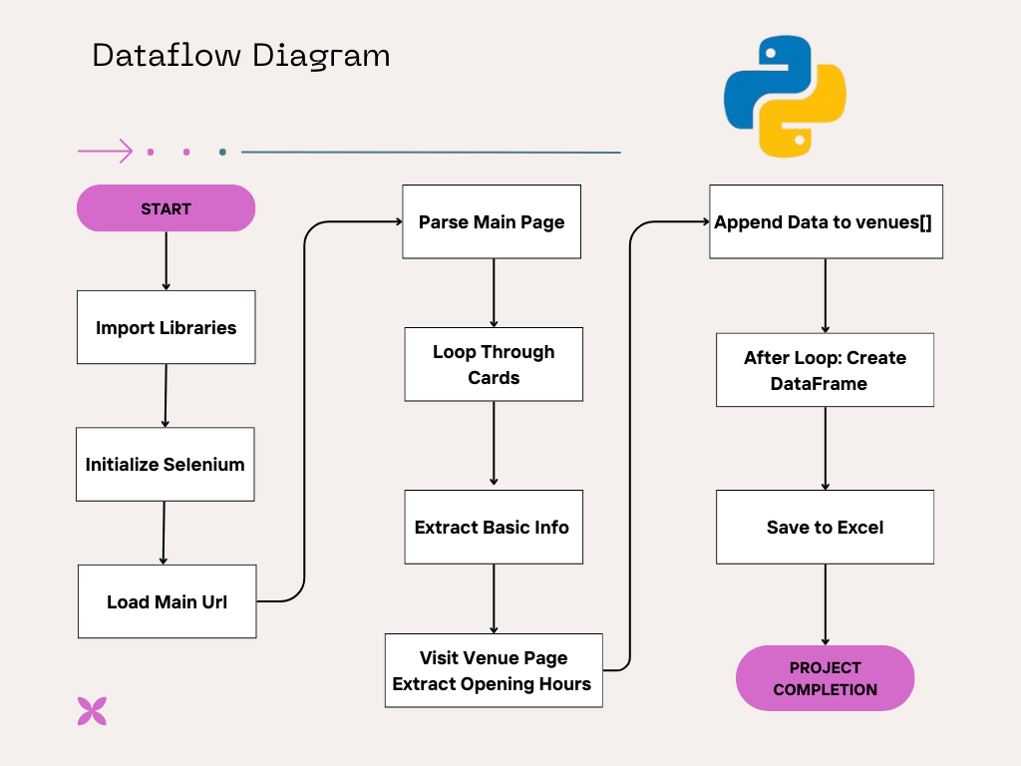

6. Conclusion:
This project successfully demonstrates an efficient and automated approach to extracting structured data from Fresha’s dynamically rendered Dubai venue listings. By leveraging Selenium to load JavaScript-dependent content and BeautifulSoup to parse the HTML, the script accurately captures essential information such as venue details, services, prices, gender specifications, and weekly opening hours. The collected data is then organized and exported into a well-formatted Excel file, making it easy to analyze, compare, and utilize for research, business insights, or competitive benchmarking. Overall, the project provides a strong foundation for scalable web scraping solutions and can be expanded further to cover additional cities, extract more detailed fields, or integrate advanced analytical tools.

